- Write down the likelihood function corresponding to a binomial model for the observed data, in terms of the parameter θ representing the population prevalence. [4 mark]

θ¹³(1-θ)¹⁷²

- Plot a figure, with clear axis label and formatting, showing the likelihood function for θ ranging from 0 to 1. [4 mark]

logL <- function(theta){
13*log(theta) + 172*log(1-theta)}
curve(logL, from=0, to=1, las=1,
xlab=expression(paste('Prevalence (',theta,')')), ylab='log(likelihood)')

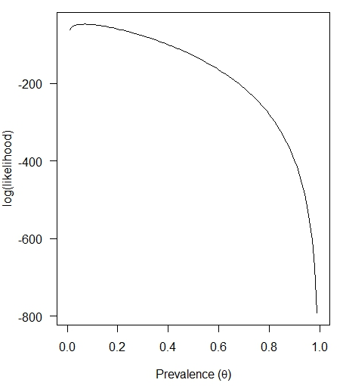

3. By finding the parameter value which maximizes the likelihood function, or otherwise, quote the maximum likelihood estimate of θ. [3 mark]

logLop <- optim(0.01, logL, method="Brent", lower=0, upper=1, control=list(fnscale=-1))
logLop$par
[1] 0.07027027

Or the MLE estimate of θ is 13/185 = 0.07.

4. Using a formula, approximation, or simulation, give the 95% confidence interval of θ. [4 marks]

log 𝑙(MLE estimate of θ) − log 𝑙(𝜃) < 1.92
-47.05254 - log 𝑙(𝜃) = 1.92
log 𝑙(𝜃) = -48.97
This value correspond to log 𝑙 (0.04) & log 𝑙 (0.11)
95% CI (0.04 , 0.11)

5. What is the p-value of the maximum likelihood estimate of θ? You may decide the H0 and use any combination of formulas, approximations or simulations. [6 marks]

H0: maximum likelihood estimate of θ = 0
H1: maximum likelihood estimate of θ =/= 0

upper 95% CI = MLE estimate of θ + 1.96*se/sqrt(n)
lower 95% CI = MLE estimate of θ - 1.96*se/sqrt(n)
se/sqrt(n) = (0.07 - 0.04) / 1.96
se/sqrt(n) = 0.0153

teststat <- (logLop$par-0)/0.0153
pvalue <- pnorm(-abs(teststat), mean=0, sd=1, lower.tail=T) +
pnorm(abs(teststat), mean=0, sd=1, lower.tail=F)
pvalue
- 4.372789e-06

The p-value of the maximum likelihood estimate of θ <0.001.

6. Write a short paragraph (no more than 2-3 sentences) to convey to the director of the University Health Centre the likely prevalence of obesity among HKU undergraduates, based on some or all of the results above. [4 marks]

In a study 13 HKU undergraduates were found to be obese from a random sample of 185 undergraduate males and maximum likelihood estimate of obese percentage is 13/185 = 0.07. The total number of obese undergraduates in HKU is estimated to be 0.07 times the total number of HKU undergraduate. We are 95% confident that the actual number would be fall into the range of 0.04 - 0.11 times the total number of HKU undergraduate.

